PROJECT-2

Overview
You want to create an AWS Lambda function that can fetch data from an API periodically, and store it in an Amazon RDS instance. The function needs to be triggered every 1 minute by an Amazon CloudWatch Event. To fetch the data from the API, the function should use the requests library or a similar library to make a GET request to the API.

Project Goals
- Create an AWS Lambda function and configure it to be triggered by an Amazon CloudWatch Event that occurs every 1 minute.
- In the function's code, use the urllib library to make a GET request to the API to fetch the data.
- Use a library such as psycopg2 to connect to the Amazon RDS instance and store the data in the database.
- Deploy the function to run indefinitely, continuing to fetch and store the data on a regular basis.

Services used
- AWS Lambda: Lambda is a computing service that allows programmers to run code without creating or managing servers.
- AWS IAM: This is nothing but identity and access management which enables us to manage access to AWS services and resources securely.
- AWS RDS: It is a managed service provided by Amazon Web Services (AWS) that makes it easier to set up, operate, and scale a relational database in the cloud.
- AWS CloudWatch Events: CloudWatch Events uses rules to match events based on various criteria. Once an event is matched, CloudWatch Events can trigger one or more targets to perform a specific action.

REQUIREMENT SETUP
1.Create an RDS instance and within the “Connectivity & Security” there is a section titled “Security.” Click on the default VPC security group listed.

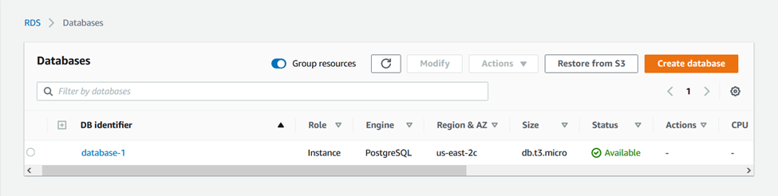

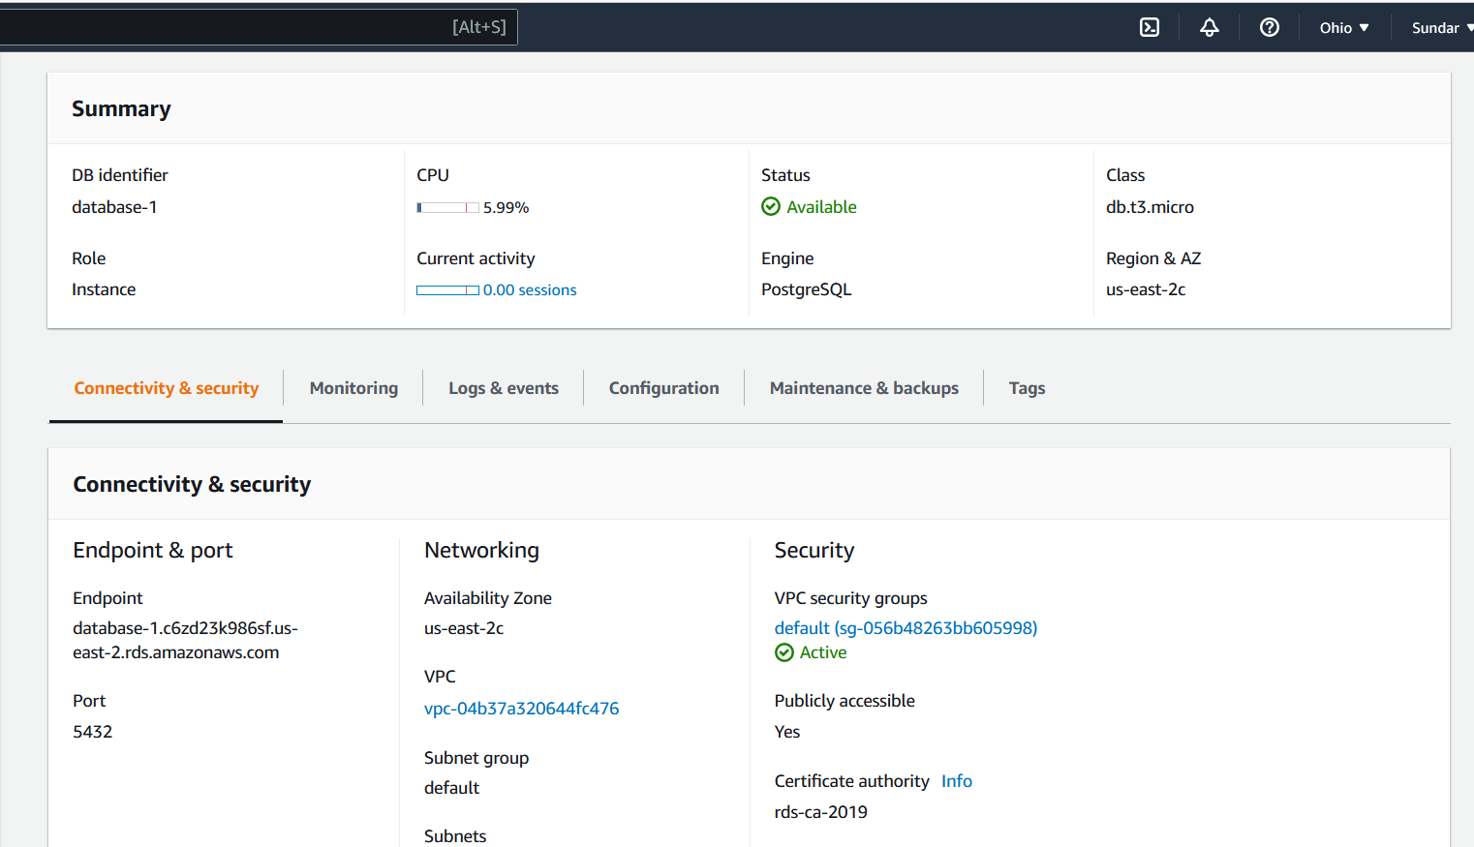

2. In order to access e RDS PostgreSQL instance from outside, we need to change the inbound and outbound rules so that we can establish connections with the RDS PostgreSQL instance.
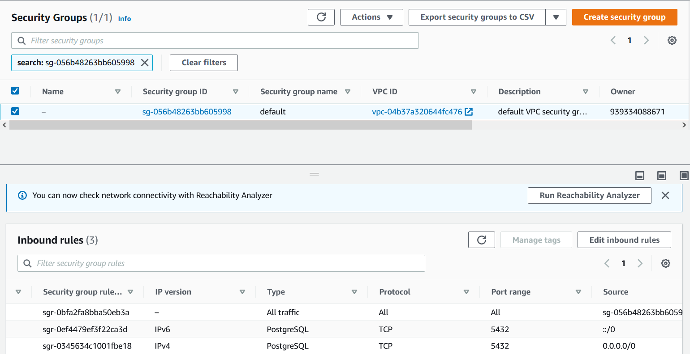

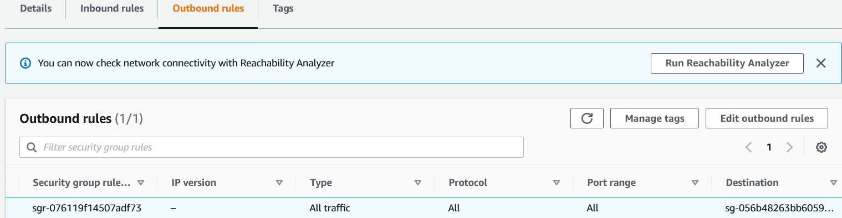

3. Creating an IAM role and grant it specific permissions to interact with services. This will allow us to retrieve data from an API in a Lambda function and store it in an Amazon RDS instance.

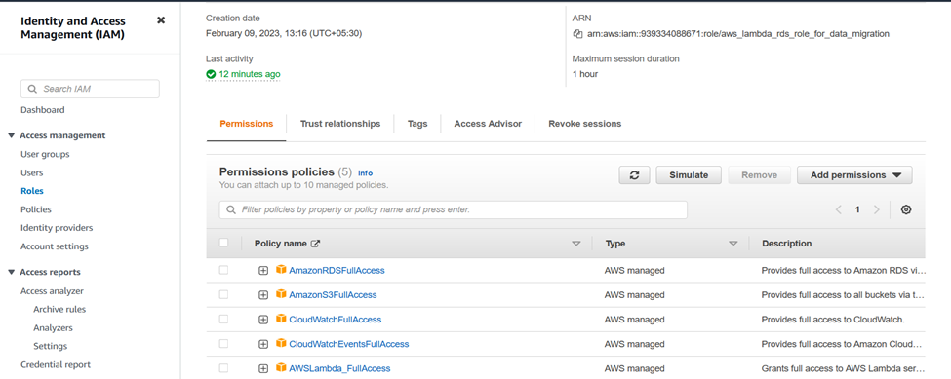

4. Create an AWS Lambda function and attach the specific IAM role that allows fetches data from an API and stores it in an Amazon RDS instance.

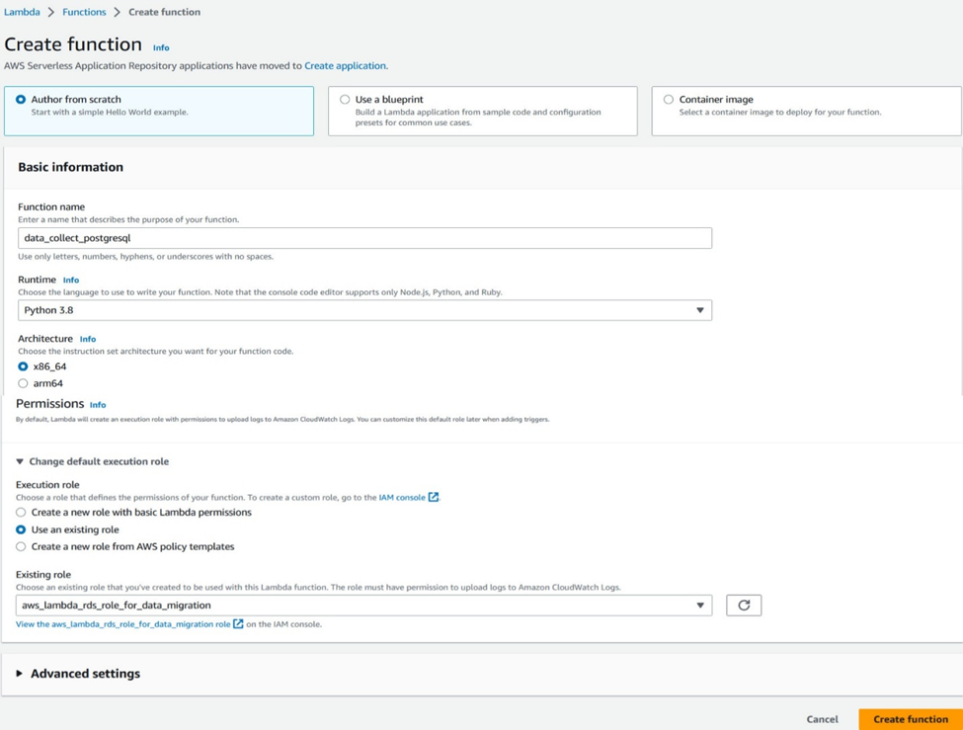

5. In the Lambda function, we cannot install libraries using pip, so we are adding a layer named 'python_psycopg2' that contains the required libraries.

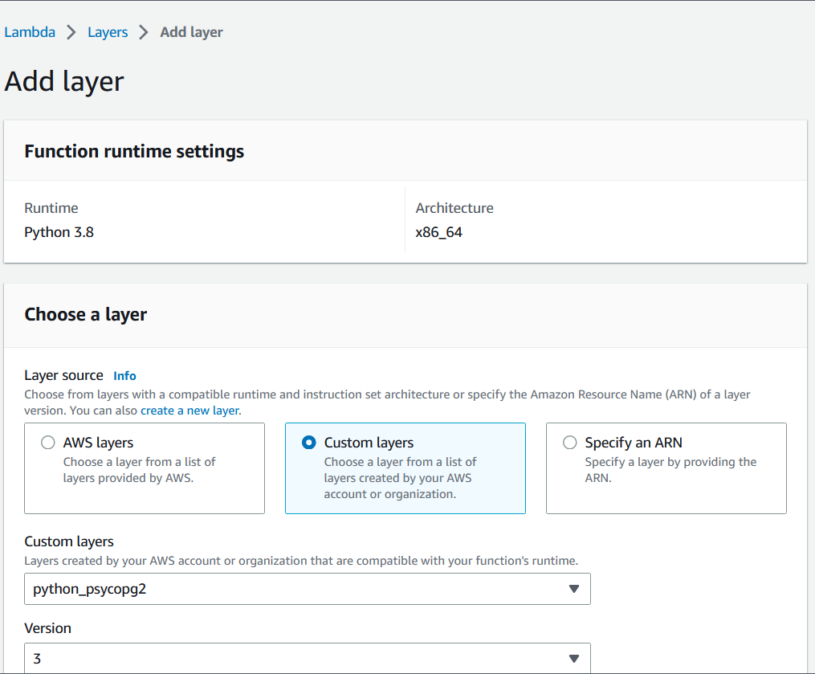

6. Create a Lambda function with python code and execute a test deployment from within Lambda to verify that the code works as intended.

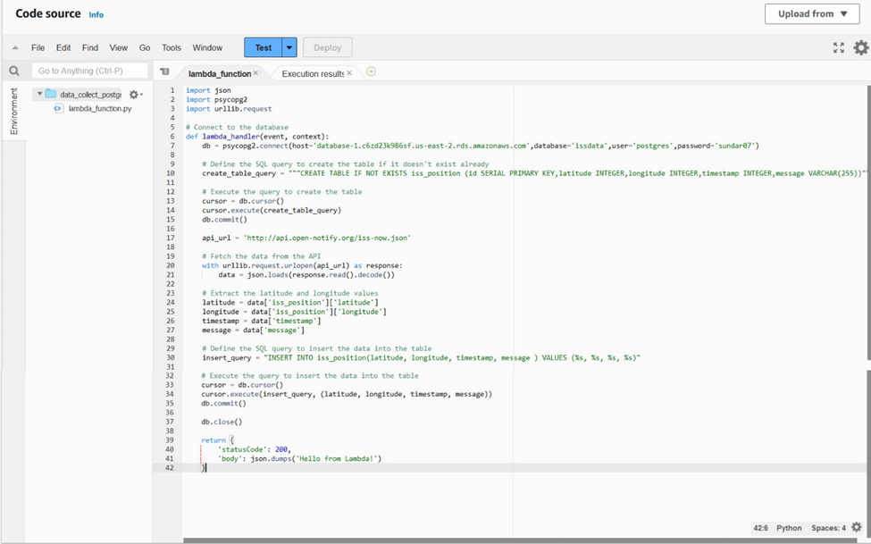

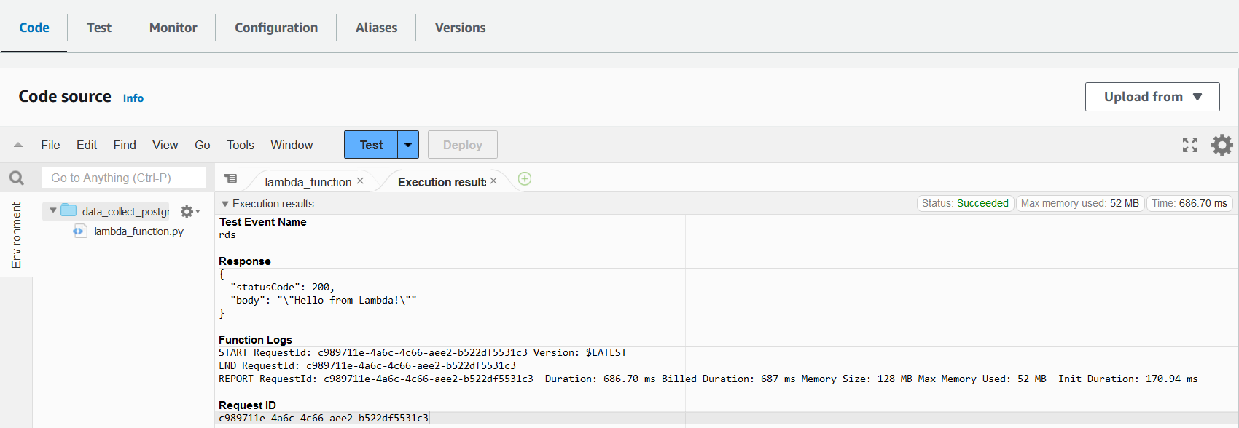

6. Connect to the PostgreSQL RDS instance using a pgAdmin UI to view and query the database.

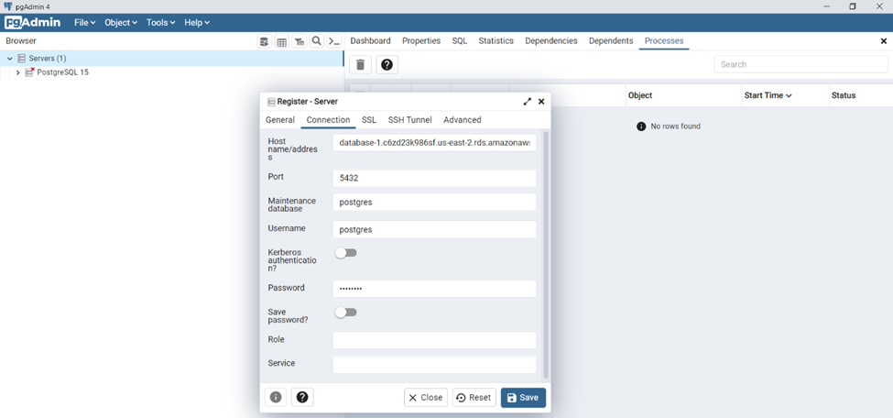

7. Create an Amazon CloudWatch Event that triggers the Lambda function every one minute. This Lambda function will periodically fetch data from an API and store it in an Amazon RDS instance.

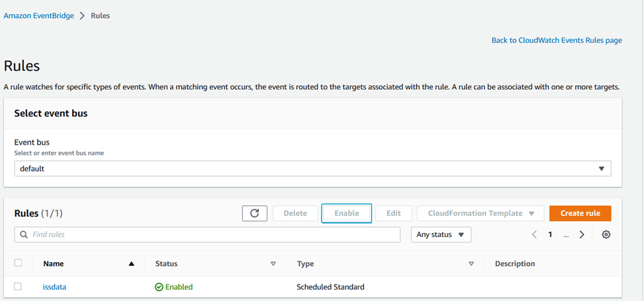

8. The CloudWatch Event trigger and Lambda function are working correctly, and you can see a screenshot below of the data that has been inserted.

